

217, Sheikh Rashid Building

P.O Box 56272, Dubai

United Arab Emirates

Tel: +971 4 2973236 / 04 2974007

Email: uae@verbat.com

PROJECT   
PROPOSAL

**IOS Application for Construction Project Defect Management**

|  |  |
| --- | --- |
| **Prepared for:**  **Kaizen asset management services proposal**  **Sinoj Kurain** | **Submission Date:**  09 March 2017  **Proposal ID:** SW/12122016/1245/1 |

___________________________________________________________________________________________________________________________________________  
Conﬁdentiality Notice: This Proposal is conﬁdential and contains proprietary information and intellectual property of Verbanet Technologies LLC. Neither this proposal nor any of the information contained herein may be reproduced or disclosed under any circumstances without the express written permission of Verbanet.

© 2017 by Verbanet Technologies LLC. All rights reserved. Confidential.

___________________________________________________________________________________________________________________________________________

Project Contacts

|  |  |
| --- | --- |
| Client Information | |
| Project Name | iOS Application for Construction Project Defect Management |
| Client Name | Kaizen asset management services |
| Client Address |  |
| Phone Number |  |
| Contact Person |  |
| Contact Person Email |  |
| Contact Person Phone Number |  |
| Contact Person Fax Number |  |
| Verbat Information | |
| Contact Person | Ms. Joyce Daniel |
| Contact Person Phone Number | 04 2973236 |
| Contact Person E-Mail | Joyce.daniel@verbat.com |
| Address | PO Box 56272, Dubai |
| Physical Address | Flat 217, Sheik Rasheed Building, Hor Al Anz East, Dubai |
| Project Information | |
| Proposed Technology/Methodology | - |
| Anticipate Start Date | NA |
| Proposal Valid For | 30 Calendar days from the submission of the proposal |

**Table of Content**

1 Executive Summary 5

1.1 Solution Objective 5

1.2 Advantages of Proposed Solution 7

1.3 Why Verbat 7

1.4 Key Differentiators 9

1.5 Underlying Support Services 10

2 Functional Specification 11

2.1 Admin (Web Application) 11

2.2 Users (IOS App) 11

3 Application Workflow 12

4 Assumptions 13

5 Out of Scope 13

6 Technology Solution 14

6.1 Technical Configuration 15

6.1.1 Development Tools 15

6.1.2 Browser Compatibility for Web Admin 15

6.1.3 Hardware Interface 15

7 Delivery Management 15

7.1 Project Management 15

7.2 Roles and Responsibilities 16

7.3 Phase Delivery Activity summary 17

7.4 Project Implementation plan 17

7.5 Deliverables 17

7.6 Release Planning 18

7.7 Risk and Contingency planning 18

8 Change Management 20

9 Project Effort & Timeline 21

9.1 Effort Estimate 21

9.2 Delivery TimeLine 21

10 Commercial overview 22

11 Miscellaneous 23

11.1 Warranty 23

11.2 Acceptance Criteria 23

11.3 General Terms and Conditions 23

11.4 Assumptions and Dependencies 24

11.5 Source Code & Intellectual Property Rights 24

12 Our Clients 26

# Executive Summary

Kaizen asset management services (here after referred to as “Client”), is an integrated property services company, offering a range of specialist services for all of your property needs. The client has established the most comprehensive and professional property service organization in Dubai. The client has request Verbat technologies to develop an IOS application that tracks defects in construction projects and generates various reports on the status of defects. The application is meant to capture r a buildings journey from inception, planning, facility management and handover.

Application Development is an area where Verbat has in-depth knowledge and expertise. Being the pioneers in Web based and windows based solutions across the major verticals, we are sure to help you enhance your customer engagement to drive differentiation. We bring proven methodologies and processes, global expertise in application development, and a legacy of best practices and ready-to-fit frameworks to expedite the development cycle and reduce the total cost of ownership.

Verbat is pleased to have received the request to submit the proposal and values it as a great opportunity to have a long term & mutually beneficial association with the client. Verbat has gone through the requirement and presents a technical proposal for the requested system. With the focus of delivering value to client, Verbat proposes a managed solution model for this requirement.

## Solution Objective

The client has requested Verbat technologies to extend the functionality of an in-house application designed for their engineers to create inspection reports out of different issues recorded in their various floor plans. Application should allow the floor plans to be snagged so that issue details can be recorded. The primary purpose of the application is to manage defects in the construction of a building including layer management ( Electrical, plumbing, architect)

The scope of the system includes

* Study, Design, Development & implementation of RBTMS
* QA & UAT
* Application documentation (Wireframes, Requirements, Specifications & Test Cases)

.

**The main features of the IOS application are listed below**

* Users
  + User login
  + Signup
  + Add User
* Projects
  + Add Project & Project image
  + Add project floor plans to each floor or section
  + Add issues  , add pictures and notes
  + Tag images for issues
  + Progress percentage
  + Add deadline to a project
  + Status of the issues by Open , Solved , Out dated , Waiting for sync
* Add trades
* Reports
  + Access and tracking
  + Keep track of each issues with the user
  + Status of the issues by Open , Solved , Out dated , Waiting for sync
* Export report by  issues , by plan , by floor , by project , by author
* Sync data from multiple users
* Reports to be saved as PDF

Verbat’s Solution architects have conducted a thorough research on the requirements and have come to the conclusion that our proposed solution, which is detailed further in this document, will meet the requirements put forth by the client. And the proposed solution will be delivered in a phased approach as per Verbat‘s managed solution model.

**Strong and Scalable platform:** The platform proposed will be strong and scalable enough to accommodate future enhancements such as scheduling, auditing & logging, push notifications etc.

**Accelerated solution:** The framework would act as a solution accelerator. It would provide the basic building blocks which could be reused in future for building new components and features as part of enhancements

**High performance:** The light weight framework used consumes fewer system resources thereby making the application perform faster

* System shall be available 24/7
* System shall be performant without any lags or delays
* System should be accessible by up to 15 people at a time
* System Shall be able to store up to 10,000 soldier details at a time

**Security:** The application will be developed considering various aspects of security.

* Only authorized personnel shall have access to the system

## Advantages of Proposed Solution

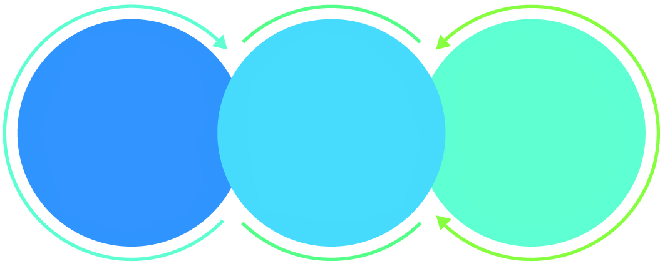

01

Agile development offering reliable, scalable and secure solution

02

Smooth transition and quicker completion of processes

03

User friendly interfaces enabling easy navigation between screens

## Why Verbat

Globally Accredited

Software Consultation Partner

Spearheaded by a   
team of Technology and   
Management Leaders



Over 16+ years of customer experience with Global   
Corporations

Service in Banking, Retail, Logistics, Construction & Contracting, Fashion, Manufacturing, Hospitality, Automotive, Healthcare and Government sectors

IT Strategy, Application Development and Maintenance, Testing Services, Information Management and Digital Marketing efforts



## Key Differentiators

Delivered digital transformation expertise to global customers for over a decade by following industry best practices to maximize ROI for client

Keen technology intelligence combined with aggressive market research to deliver solutions that achieve results with measurable value

Enable access to global consulting expertise with strong local market and business knowledge

Commercial Model that is customizable for your business needs

Reuse of code libraries for Rapid Application Development

1,000,000 plus man-hours of expertise in technology frameworks spanning Microsoft, Open Source, mobility platforms and other proprietary IT technology

Partners top technology vendors to bring in the latest and best services in integration, collaboration, and development

Commercial Model that is customizable for your business needs

Proven Methodologies & Processes

Investment in R & D

Strong Local Presence

Flexible commercial Models

Technology Associations

Code Repository

Software Development Experience

Offshore Development Centre

## Underlying Support Services

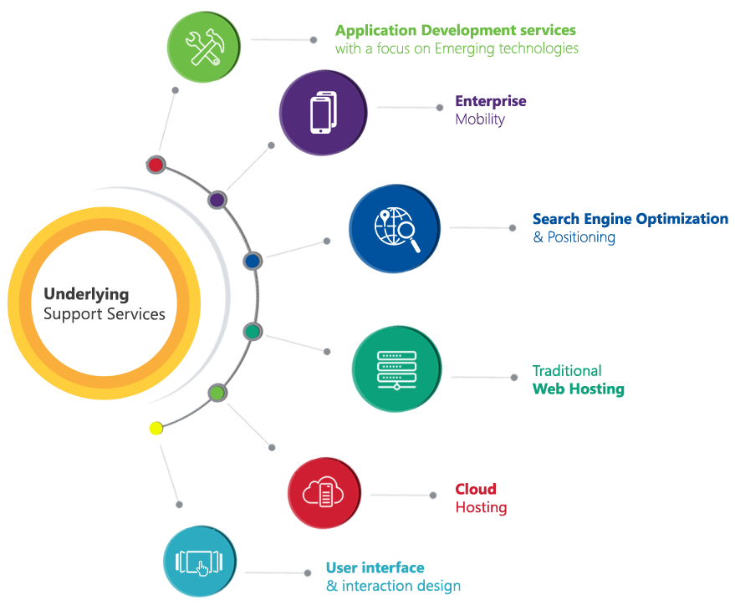

# Functional Specification

The project will be developed in a single phase. The project has two interfaces: a mobile interface for the engineers who oversee the project along with a web based interface for the administrator who sets up and manages the project. Work can be started in parallel for the two interfaces.

Verbat will design & develop the solution with focus in the areas mentioned below

## Admin (Web Application)

* Create Users
* Create Departments
* Assign users to departments
* Create project
* Create Observations
* Create Floors
* Add floor plants (images)
* Create units
* Add unit plan images
* Create companies (contractors)
* Assign trade to companies

## Users (IOS App)

* Add observation to floor plan
* Add completion by date
* Add pictures to observations
* Add comments to pictures
* Assign status to observation
* Resolve issues in the observation
* Assign users to observation
* View reports based on
  + Projects
  + trades
  + Trade and projects
  + Status of the projects
  + Observations per project
* Export report to PDF format
* Sync data with server

# Application Workflow

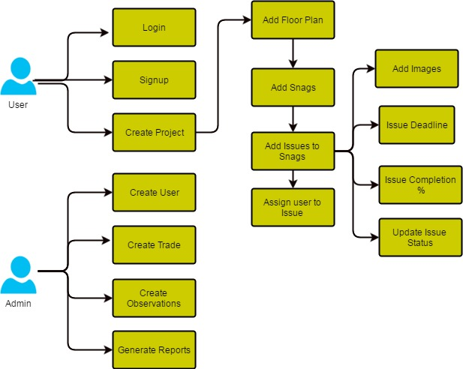

1. Administrators create new users, departments or trades, observations and generate reports
2. Users belonging to different departments or trades can login or register themselves
3. Users can create new projects
4. Images representing floorplans can be attached to projects.
5. Areas in the image can be marked for issues
6. Users pinch (or similar) on the image to create issues.
7. Issues are assigned to a trade and observations related to that trade can be added to the issue list
8. Additional Images can be attached to the observations
9. Issues can be assigned to users
10. Issues have a deadline before which it has to be resolved
11. Issues can have a status of Open , Solved , Out dated , Waiting for sync
12. The application works online or offline mode
13. All data entered into the application will be synched to the server.

# Assumptions

The project solution and technology is created from the initial understanding of the requirement shared with Verbat through mails and meetings. The proposed solution is based on the following assumptions;

* Color theme shall be provided by the client
* The client shall provide the branding guidelines
* Client shall provide licensed images and logos in specified size & format
* Client will provide the source code of the existing IOS application
* Client shall approve the wireframes and prototype of the mobile application and web application before development work starts

# Out of Scope

With the ever evolving digital market, the requirement needs should be clear to both the parties involved, hence the importance of mentioning the out of scope details of the project. Following are considered to be out of scope while creating this proposal.

* Purchase of images, fonts
* Adding new features to the application other than mentioned in this proposal
* Any language other than English
* Manual data entry
* Database migration
* Content writing
* Hosting Infrastructure
* Annual Maintenance Contract ( Bug fixing, debugging, enhancements, develop new modules)
* Physical deployment at client’s site

# Technology Solution

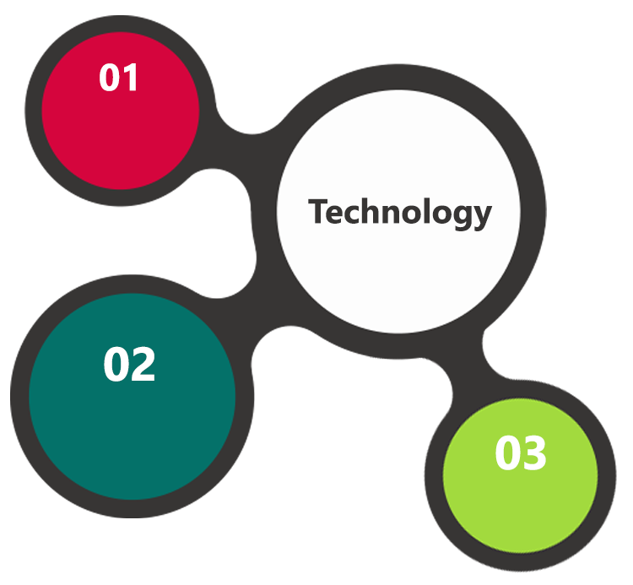

IOS Framework  
Xcode

Cocoa

MySql  
Linux  
Web Services

AJAX  
JavaScript  
JSON

The application will be developed using open source technologies employing a mix of web services and a web interfaces to configure the application. The admin portion of the application will be a web based application used for configuring the project. The user portion of the application will be IOS mobile phone application which can work both in an offline and online mode. The Mobile app will sync with the web app when the device is in the vicinity of a mobile network.

## Technical Configuration

### Development Tools

* Xcode, Cocoa, PHP
* Mysql
* Web services

### Browser Compatibility for Web Admin

* Chrome 56.0
* Firefox 51.0
* Internet Explorer 11

### Hardware Interface

The application is reliant on hardware interfaces to provide a seamless automated user experience.

* Computer with Windows 8 or 10 OS
* IOS Mobile device

# Delivery Management

## Project Management

The Verbat development center strictly follows industry standards on quality. The project management is process governed by the Verbat Quality Management system and is put to verification through internal audit programs that happen from time to time.

Verbat will dedicate a project manager for the proposed implementation. Verbat proposes Client to identify one project manager who will be driving activities to be undertaken by Client to be the single point of contact for Verbat.

## Roles and Responsibilities

Verbat will assign a dedicated Project Manager/Project Lead to lead the project, who will be the first point contact for Client. He/she will be responsible for planning and managing the various activities within the project. He/she will work closely with Client Project Manager, to give periodic status updates and ensure high level of visibility and comfort on the progress of the project.

The Project Manager/Project Lead will lead the co-ordination between Verbat and Client, thus enabling smooth transitioning of Client requirements to the Verbat’s offshore delivery team, and provide visibility as well as comfort on the progress of the services to Client.

He/she will have periodic meetings with Verbat’s Senior Management, thus ensuring Verbat’s Management commitment and focus on Client initiatives.

*Note: detailed qualification and experience of the persons involved in the project will be shared be finalizing the project on request*

## Phase Delivery Activity summary

|  |  |
| --- | --- |
| Activities | Description |
| Detailed requirement Analysis | Verbat team to conduct detailed study of requirement for the phase. If clarification is required, team will reach out to Client for more information and/or time for discussions. |
| Software Requirement Specification document (SRS) | Once the requirement analysis is completed, Verbat team will submit the SRS document for approval |
| UI/UX Design, Prototyping | Based on the SRS, Verbat UX/UI team will work on the UI/UX of the screens and submit a prototype for approval |
| Functional Specification Document (FS) | Once the Prototype. UI/UX is approved, Verbat shall submit an FS document for approval. |
| Development | Actual system development starts based on the FS. This involves detailed design and software development of Web Admin, API & iOS and Android mobile app. |
| Testing | Test Planning, test plan creations, internal, integration testing and user acceptance testing. |
| Deployment | Deploying the latest built in the Verbat Test Server. |

## Project Implementation plan

Verbat will be providing the solution in a phased approach which ensures minimum viable solution for quick wins with core focus on the long term business objective and outcome. Once the implementation of phase 1 is over, Verbat will initiate the application maintenance process which continues to extend after the implementation of successive phases.

## Deliverables

* Software Requirement Specification Document (SRS)
* Wire Frames for Key Screens
* Functional Specification Document (FS)
* Fully Developed & Tested Application
* Test Cases
* Fully commented source code
* User Manual (English)
* Install shield executable

## Release Planning

* Client will be informed about the release date and time through email.
* Client performs the UAT

## Risk and Contingency planning

Verbat has identified various risk factors associated with this assignment and understands the impact of these risk factors on the project schedules. The objective of this section is to highlight for both Verbat and client, the risk factors, to analyze the impact of the risks on project execution, and to propose strategies to control and reduce the impact of the risk factors.

These various risks, which could arise during the project, are tabulated below along with mitigation implementation.

| Type of risk | Impact | Risk Mitigation | Risk Handling |
| --- | --- | --- | --- |
| Scope Creep | H | Functions and features will be detailed in system requirement documents and will go through client approval. Once this document is approved, any change to requirement will go through change management review for possible impact assessment. | Proper change management procedure will be implemented. |
| Delay in customer feedback | H | The plan is prepared with enough lead-time for customer reviews and approvals.  The customer is indicated with the dates when the document is expected after review and approval. | The request for feedback will be escalated if not attended at the right time so that the schedules are not affected. Deemed acceptance criterion is set up front and will be followed. |
| Non-availability of necessary software’s, frameworks, database instances and infrastructure at client’s hosting environment(If hosting support is provided by Verbat) | M | Client will be informed in advance on these requirements. | Possible impact to schedule. |
| Manpower attrition | L | All efforts would be made to ensure process dependence rather than being person dependent. As a risk mitigation plan Verbat will train backups. | A new person will be identified as early as possible, provided the required project-specific training and mentored by the senior members of the team to minimise impact of attrition on the project. |

*H-High, M-Medium, L-Low, NA-Not Applicable*

# Change Management

Any addition which comes out of the project scope, upon and after the launch of the tool will be considered as change management. Verbat recommends the following change management procedure for the same.

* Any change which comes out of the project scope, which was discussed, documented, and mutually approved by both the parties in the requirement stage, will be carried out only through raising a change request.
* Change request will be studied and an impact analysis on the existing work flow will be performed.
* On finalizing the impact, effort estimation for the change will be calculated and raised as additional requirement.
* Verbat will initiate the change request only after getting a formal approval from the client for the additional changes raised.
* Any change from the scope will be charged at **AED 1200 per man day effort** and approval from the clients will be availed before commencing on any change management.

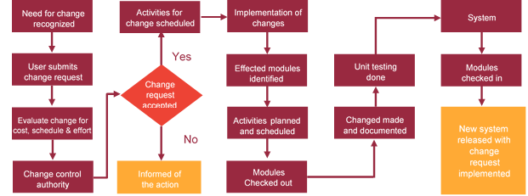

# Project Effort & Timeline

## Effort Estimate

The effort estimated for delivering the application as specified in this document will be as below:

|  |  |  |
| --- | --- | --- |
| **Activity** | **Effort (Man Days)** | |
| Initiation & Requirement Analysis | | 16 |
| Application Development | | 102 |
| Testing of the application | | 38.5 |
| Go Live | | 07 |
| **Total Man Days** | | **163** |

## Delivery TimeLine

|  |  |  |
| --- | --- | --- |
| **Activity** |  | **Delivery Days** |
| Defect management application for construction projects |  | 70 |
|  |  |  |

# Commercial overview

|  |  |  |
| --- | --- | --- |
| **Description** | | **Cost (USD)** |
| Defect management application for construction projects | USD XXX,XX.00 | |
| **Total** | | **$ X,XXXX.XX** |

# Miscellaneous

## Warranty

Verbat shall provide a bug ﬁx warranty at no additional cost for 30 days from the date of acceptance of the project, for correction of any errors in the developed application that may be attributed to Verbat.

However, this does not cover modifications by Client, or use of the application on an environment other than the proposed environment, or other circumstances outside Verbat’s reasonable control. In such a case Verbat reserves the right to charge for its services.

All error corrections will be executed at Verbat India office. In the event of any need for on-site work, all expenses incurred for such trips will be payable to Verbat by Client.

## Acceptance Criteria

* UAT sign off should happen within 14 Days from the release of each module/ Phase and the acceptance confirmation needs to be mailed to Verbat failing which Verbat will consider the project as approved by the client.
* Any comments or reason for rejection need to be documented and the same needs to be sent as an email from the official mail id of client to Verbat.

## General Terms and Conditions

* Offer Valid for 30 calendar days from the date of submission of the Proposal
* An average of 20 working days are assumed in a month
* This proposal and all technical/ functional specifications have been derived or concluded from the data shared via email / information's transferred during the initial requirement analysis meetings and conversations. Verbat reserves the right to amend the terms of this proposal, should the SOW terms, functional features and functionalities change during the course of the project
* The applications will be built as per the specifications agreed mutually. Any changes will be executed through a deﬁned change management process between both parties
* All Source Code and other project artefacts would adhere to the Verbat document templates and internal coding standards
* Acceptance criteria shall be based on the clauses which were mutually discussed between Verbat and client at the Requirement Analysis phase and the same will be documented and approved by both parties through official emails
* Final deployment to production server pursuant to completion of all payments

## Assumptions and Dependencies

* During the requirement gathering phase, authorized personnel from the Client’s side is expected to be available for discussion and finalizing the HLD (High Level Design), before development commences.
* Type of reports and formats, if under the scope of the project, needs to be specified by Client before project sign off.
* Workflows need to be specified/ confirmed by client before project signoff.
* All queries regarding the client requirement and any queries which may hinder the project advancement at any stage should be answered by the client within 24 hours from the time of initiation, failing which the time delay will get added to the actual effort which was estimated.
* Verbat assumes that all sign-offs from Client will be provided within agreed and specified timeframe.
* Client will provide all the necessary contents, both text and image, before starting the project in the format suggested by Verbat (if any).
* The client should provide the relevant information and data well in time for the execution of a related activity. Non- availability of this information or data may lead to an interruption of work which may result in a delay in delivery as well as additional costs to the client.

## Source Code & Intellectual Property Rights

* Upon completion of the Project and 100% completion of the payment, client will have access to the source code except for propriety codes, developer tools and third party application / modules like Microsoft Dynamics Products, Share Point LMS etc.
* The solution offered will be the intellectual property of the client and will be made available to the client on an “unlimited license” basis.
* Modifications by third party/person: No person or organization, other than Verbat or any person authorized by Verbat in writing, has any permission to modify/change the software Solution to be eligible to get continued support from Verbat as per the support terms defined under this document.
* Liabilities/Damages: Verbat accepts no liability or damages of any kind arising out of use or non-use of the software delivered. The responsibility of testing of software lies with Client.

# Our Clients

**UAE University**

Education

Transportation

**Canada Cartage**

Construction

Services

Finance

We look forward to hearing from you soon and hope that you will give us the privilege to work with you in meeting your business goals. Thank you.

Thank You



©   
1999 - 2017. All Rights Reserved   
Verbanet Technologies LLC  
www.verbat.com